Linguistic Prescriptivism Workshop(s)
In his lecture at the University of Leeds, Peter Trudgill described prescriptivism as ‘the bizarre notion that some forms of language are “right” and others are “wrong”’. He went on to say:
This notion is propagated by people who feel they have some kind of entitlement to prescribe how other people should speak and write.
This is most often how they speak and write themselves – or think they do.
These people feel they have authority to instruct the rest of us that certain grammatical forms and pronunciations and words which are used by ordinary people in their everyday lives are “incorrect”.
What motivates them is not entirely clear. But they typically make these assertions without any supporting evidence and with total confidence.
The purpose of this workshop is to explore these ideas further. Specifically, the aims are:
- To develop an understanding of what linguistic prescriptivism is and why it is still a dominant force in society.
- To understand that linguistic prescriptivism is not a new phenomenon but that the specific linguistic features it targets may change.
- To be able to identify the kinds of linguistic features that are usually the target of linguistic prescriptivism and consider why such forms are so highly stigmatised.
- To identify the social groups whose language is being judged as “incorrect”.
- To understand and critique the assumptions about language that underpin linguistic prescriptivism.
Below are three texts for you to analyse and discuss.
Text 1 is a letter that was sent to parents of pupils attending a primary school in the West Midlands. It contains a list of local dialect phrases and other linguistic features that will no longer be ‘tolerated’ in the school’s classrooms.
Text 2 is taken from a 19th century etiquette manual, A Manual of Etiquette with Hints of Politeness and Good Breeding, by Daisy Eyebright (1813). It discusses the use of ‘slang’ terms.
Text 3 is a ‘personal speech coach’ app designed to help individuals ‘train against verbal habits and practice speaking articulately, confidently and without all of those “likes” and “sos”’
When working with these texts, read them carefully and make a note of what stands out to you as particularly interesting, significant or anomalous. Consider the questions that follow and discuss in small groups.
Text 1 is a letter that was sent to parents of pupils attending a primary school in the West Midlands.
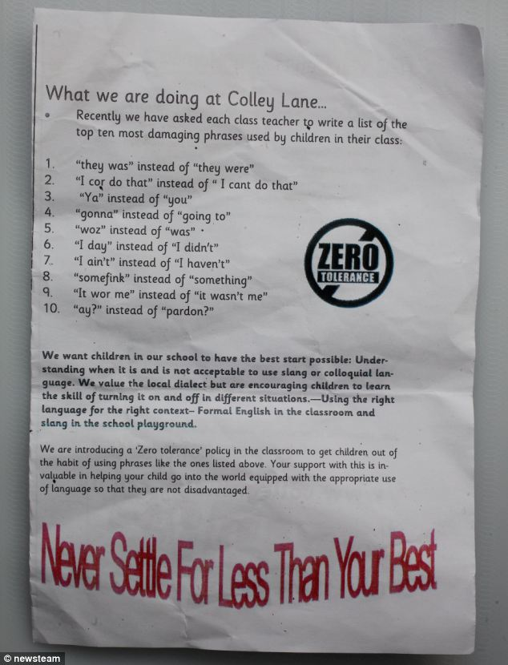

Source: http://www.bbc.co.uk/news/uk-england-birmingham-24941692
Things to think about:
- Do you recognise any of the banned words/phrases? Would you use them yourself? If not, why not? Have you heard others using them? Who?
- If you had to draw up a similar list based on the language spoken in your local area, which words, phrases and pronunciations would you include? Are there particular features of your local dialect that people tend to comment on and/or judge as “incorrect”, “wrong”, or “damaging” to speakers? Why do you think this is the case?
- The letter refers to ‘slang’, ’colloquial language’ and ‘local dialect’. How are these terms being used in the letter? How would you use them?
- Are there any features of your local accent and dialect that you try to avoid in certain situations or with certain people? If so, why? Did anyone teach you to change your language depending on the context? Do you think that explicit instruction about this is necessary (as indicated in the letter)?
- Do you think that this kind of ‘zero tolerance’ approach to local dialect at school will work? What are the potential consequences of this kind of intervention?
- Has anyone ever corrected the way that you speak? In what context? How did it make you feel?
- Do you think that speakers who use a local dialect are ‘disadvantaged’? If yes, in what ways?
Text 2 is taken from a 19th century etiquette manual, A Manual of Etiquette with Hints of Politeness and Good Breeding, by Daisy Eyebright (1813).
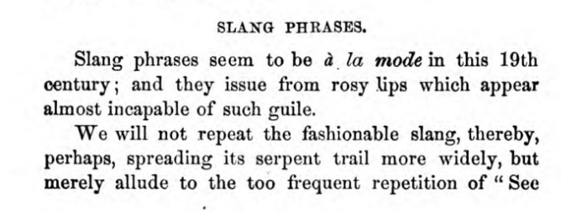

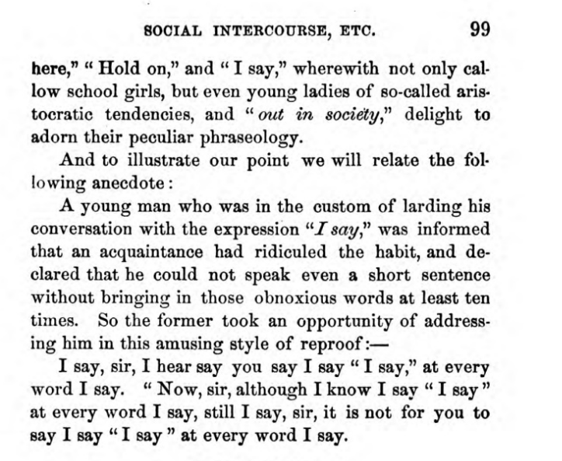

Things to think about:
- How is the term ‘slang’ being used in this text? How does this compare with Text 1?
- Which linguistic features are identified as ‘slang’? Would you use these features? If not, why not?
- The text points out that ‘even young ladies of so-called aristocratic tendencies’ use slang phrases. Women’s language is often the subject of social commentary. Why do you think this happens? Can you think of other more modern examples?

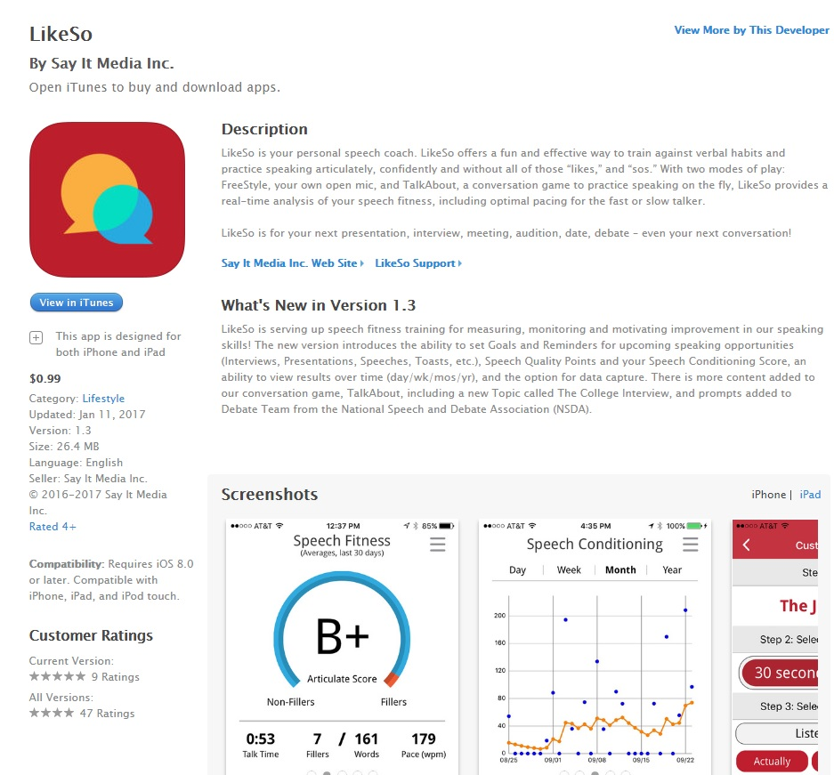
Text 3 is an example of is a ‘personal speech coach’ app
Things to think about:
- What kinds of language does this app target? Why do you think this is?
- Have you ever tried recording and analysing your speech in this way? If yes, how did you find the experience? If no, would you like to try? Do you think you would find this app useful? Or perhaps you know other people who should try using this app?
- Do you see any similarities between this app and the 19th century etiquette manual?
- Can you think of other modern examples of linguistic prescriptivism?
- Considering at all three texts (as well as any other examples you can think of), which social groups tend to be the target of prescriptivism? Why do you think this is the case? What are the potential consequences of this?

